Google Classroom

**Online Learning Platform**

Use-Case Specification: Join a class

Version 1.1

Revision History

| **Date** | **Version** | **Description** | **Author** |
| --- | --- | --- | --- |
| 05/12/2021 | 1.0 | Initial version | Nguyen Nhu Hong Phuc |
| 09/12/2021 | 1.1 | Final version | Nguyen Nhu Hong Phuc |
|  |  |  |  |
|  |  |  |  |

Table of Contents

1. Use-Case Name 3

1.1 Brief Description 3

2. Flow of Events 3

2.1 Basic Flow 3

2.2 Alternative Flows 3

2.2.1 < First Alternative Flow > 3

2.2.2 < Second Alternative Flow > 3

3. Special Requirements 3

3.1 < First Special Requirement > 3

4. Preconditions 3

4.1 < Precondition One > 3

5. Postconditions 3

5.1 < Postcondition One > 3

6. Extension Points 3

6.1 <Name of Extension Point> 3

Use-Case Specification: Join a class

# Use-Case Name

## Brief Description

* This process for user to join a specific class in Google Classroom
* For the students only
* The purpose : helping users to join a specific class in the Google Classroom

# Flow of Events

## Basic Flow:

Go to the classroom.google.com when it’s your first time choose the role “Student”. There are several way that you can enter the class for the students . The first one is to join the class with a class code , then choose the  on the top right of the page . When clicking the button , the given class code is given by the teachers / lectures and should be filled in the box .

After that , enter the right class code and choose the appropriate Google account then click the  button. The second choice is joining class with the email invitation . Clicking the  button on the top right corner to access the Google Software Service . After that clicking the  option and the browser will quickly take you to the Google Mail .Then you will receive the following information such as Class Invitation: “Name ” and lying under that is the name of the lecturer(Classroom) to all the mail of the students in the classroom and the Join button to join the classroom specifically described in the photo below .

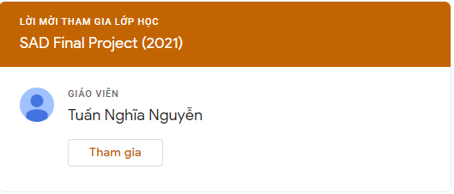

Finally it will take you directly to the classroom.google.com and the specific class will appear according to the image .

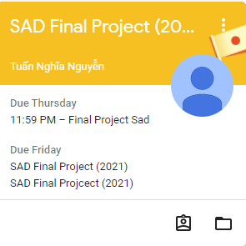

## Alternative Flows

None

# Special Requirements

## None

# Preconditions

None

# Postconditions

## None

# Extension Points

## None